10.1-inch Android rugged tablet (Android 16)
Powerful eight-core performance | 1D/2D barcode scanning | Ultimate UHF RFID reading and writing | 10000 mAh large-capacity battery life
Product Overview
This 10.1-inch Android rugged tablet is a versatile mobile terminal designed for extremely harsh industrial environments. It is equipped with a high-performance MT6789 eight-core processor (with a maximum frequency of 2.2 GHz) and the Android 13 operating system, providing smooth computing support for complex industrial applications. The device is equipped with a 10000 mAh ultra-large capacity polymer lithium battery and supports 30W PD fast charging, ensuring excellent endurance in outdoor or long-shift operations.
The most prominent feature of this tablet is its powerful data collection capability. It not only supports optional high-performance 1D/2D barcode scanning but also optional Built in Impinj E-series chip ultra-high frequency Rfid module, achieving ultra long distance reading of up to 15 meters and group reading efficiency of processing more than 1500 labels every 10 seconds. Its IP67 protection level and anti drop design make it an ideal tool for logistics warehousing, asset management, power inspection, outdoor surveying and other fields.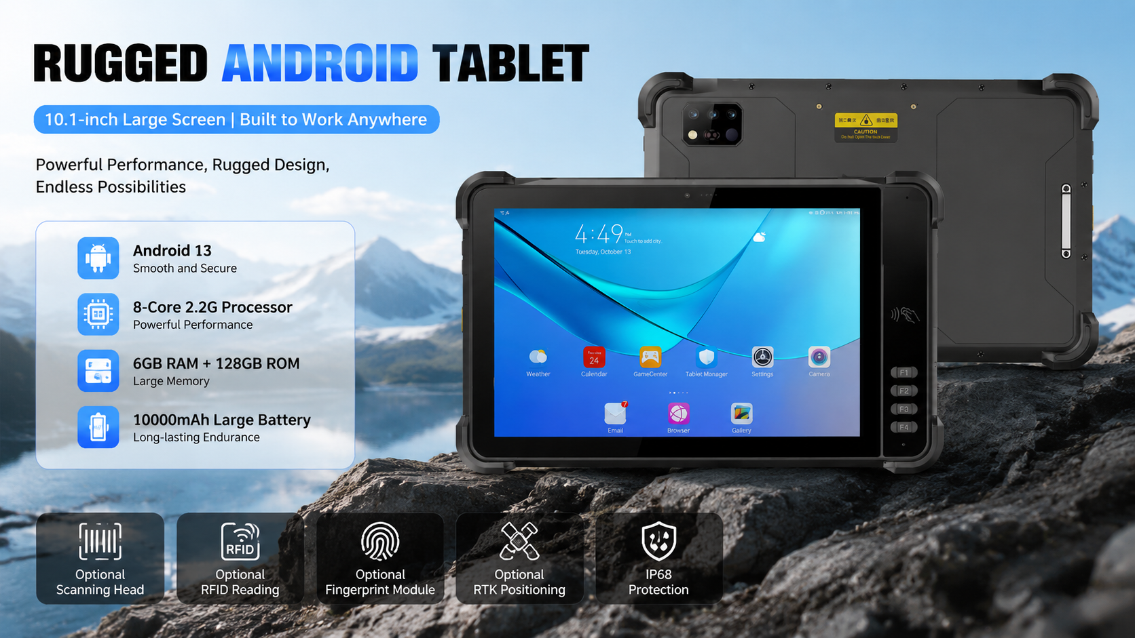

Basic Information
processor | MT6789 (2 Arm) ® Cortex-A76 core, operating frequency of 2.2GHz, 6 Arm ® Cortex-A55 core, operating at a frequency of 2.0GHz
operating system | Android 16
Memory | 8G+128G Optional:8G+256G
Expand memory | Micro SD card, supports up to 1TB
display | 10.1 inches, resolution: 800 * 1280 550 nits.  Optional: 10.1-inch/1920 * 1200/IPS 600nits/Supports glove mode/wet hand mode
Touch Screen | Capacitive screen: supports multi touch, glove touch
Rear camera | Rear 1600W pixels support autofocus and flash
Front Camera | Front 500W pixel (optional)
audio | Main MIC*1, Noise Reduction and Echo Cancellation*1
audio | Speaker (4W) * 1
prompt | 2 RGB lights
prompt | Vibrating motors
keystroke | Left: Volume +-, Scan key  Right side: Power on button  Front: 4 custom function keys
External interfaces | Left: TYPC-A  Right side: SIM card holder + TF card holder, TYPC-C
Booths | Nano SIM card * 2&Nano SIM card x 1+T_FLASH * 1
sensor | Light sensing+distance, gravity sensor+6-axis gyroscope  optional: Compass, air pressure sensor
battery | 10000 mAh polymer lithium battery  Standby time> 350 hours  Working time> 10 hours (depending on the usage environment)
Charging method | Type-C 30W PD fast charging  The charging time is 2-3 hours, using the standard power adapter and data cable
Communication Transmission
WLAN function | Dual-band 2.4GHZ/5Ghz, support IEEE 802 a/b/g/n/ac protocol
Bluetooth | Supports Bluetooth 2.1+EDR/3.0+HS/4.1+HS+5.0
GNSS | Supports GPS, Galileo, Glonass, Beidou
Wireless WAN (Data Service) | GSM/GPRS/EDGE/CDMA/UMTS/HSPA/HSPA+/WCDMA/TD-SCDMA/TDD-LTE/FDD-LTE
Wireless WAN (Network Frequency) | 2G:GSM ( B2/B3/B5/B8)  3G:WCDMA( B1/B2/B5/B8)  4G:FDD:B1/B2/B3/B5/B7/B8/B20/B25/B26/B28  TDD:B34/B38/B39/B40/B41
Optional functions
Barcode Scanning | 1D code, 2D code scanning head
NFC | Operating frequency: 13.56MHz  Supported Protocols:ISO14443A/B, ISO15693, NFC-IP1, NFC-IP2  Tag standard: M1 card(S50, S70), CPU card, NFC tag, etc  Reading and writing distance: 1-3cm
UHF RFID | Built in Impinj E-series chip ultra-high frequency Rfid module  North America: 902-928MHz FCC (NA, SA)  Europe: 865-868MHz (ETSI)  China: 920-925MHz (CMIIT)  Full frequency range: 860-960MHz (OPEN )  EPC global UHF Class 1 Gen 2 (ISO 18000-6C)  Antenna:Circular polarization, 4dBi  Up to 15 m (open outdoors, lmpinj MR6 tag)  1500+tags/10sec
Fingerprint module | FAP20 capacitive fingerprint module
Environmental parameters
Operating temperature | -20℃~55℃  *For safety reasons, do not charge in a low temperature environment
Storage temperature | -40°C~70°C (without battery)
humidity | 0~95% (no condensation)
Drop Specs | The 1 meter concrete floor fell many times
Ingress protection | IP67
Electrostatic discharge | ±15KV (air discharge), ±8KV (contact discharge)
Development support
Development language | Java
Develop APIs | Android standard interface
Structural parameters
Dimensions (mm). | 290.6*182.5*18.5mm
Weight as standard | 980g
Equipment accessories
Standard accessories | Adapters, data cables, protective films

Due to irregular product updates, if there are any changes to the content, the actual shipment shall prevail.

Provide ODM and OEM customized services
• We work closely with our partners and can provide various one-stop customized solutions.
• Appearance customization: supports customization of product nameplates, product packaging, and promotional materials.
• Hardware customization: Supports customization of functional modules and optional hardware functions.
• Software customization: supports customization of boot interface, boot program, kernel clipping, and API interface.
• Technical support: Provide SDK development kits and application software development technical services.

